To install Avenza Maps and import CFB BBRGC Map
- Go to http://www.bordenrodandgun.com/departments/tree-stands/
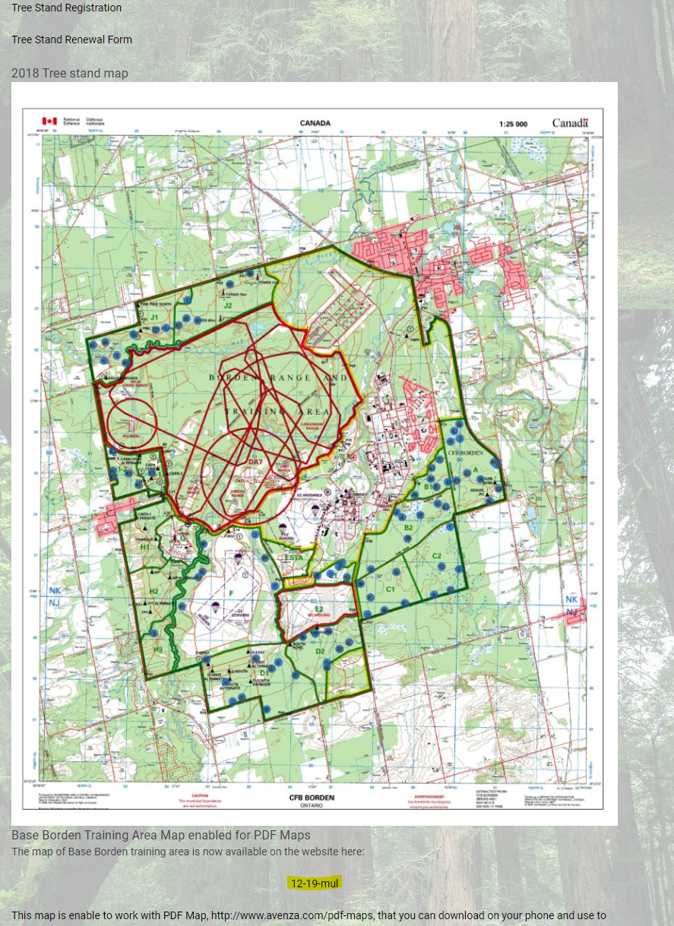
- Scroll to bottom of page and click the map link at the bottom highlighted on image below:
- Once selected copy the url address for the PDF: http://www.bordenrodandgun.com/wp-content/uploads/12-19-mul.pdf
- Download Avenza Maps from the google play store found here https://play.google.com/store/apps/details?id=com.Avenza
or from the apple store found here: https://apps.apple.com/app/apple-store/id388424049

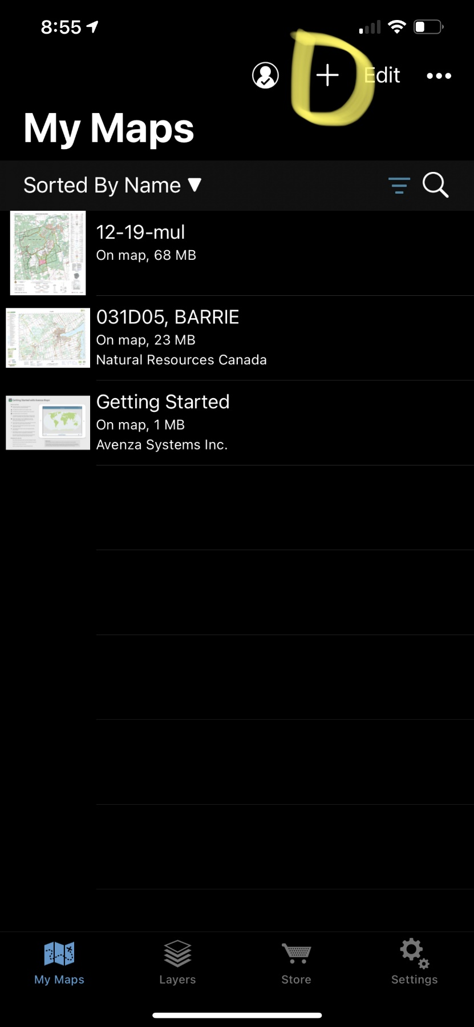
- Open app and select add map:

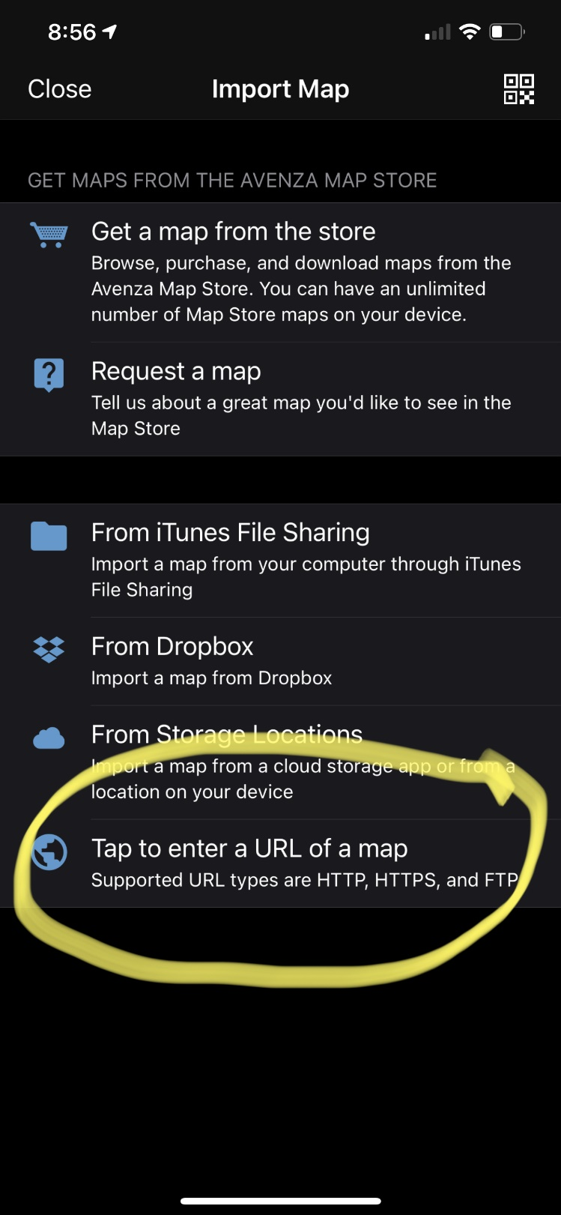
- Select Tap to enter URL of a map
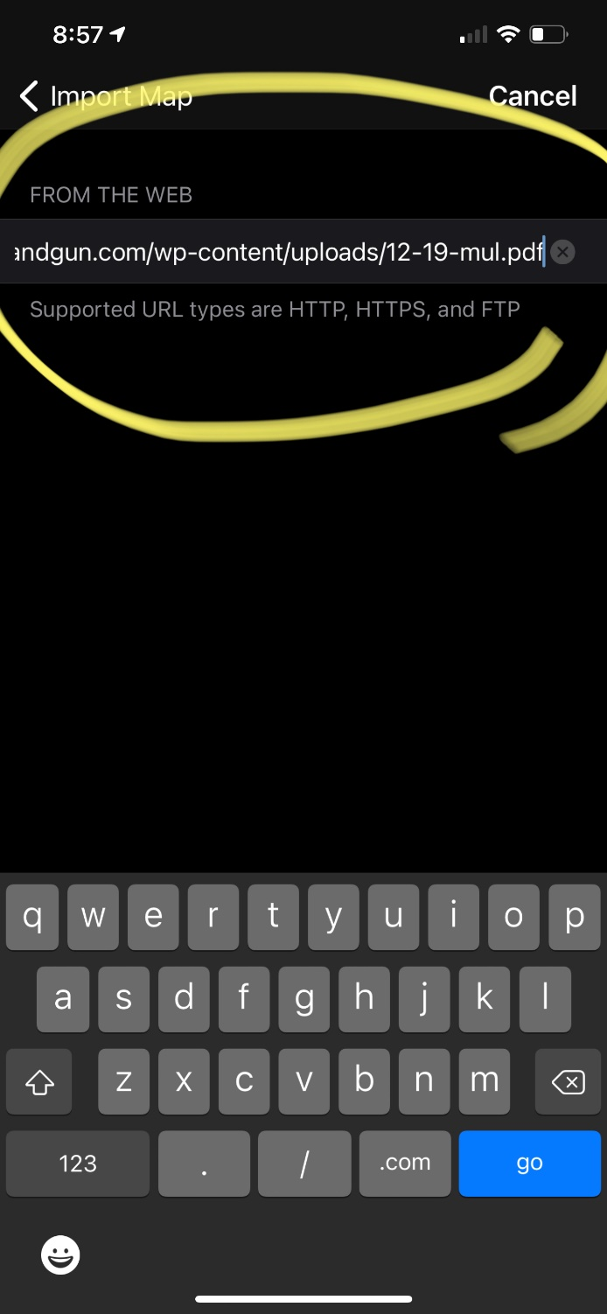
- Once URL is added and finished the app will download it

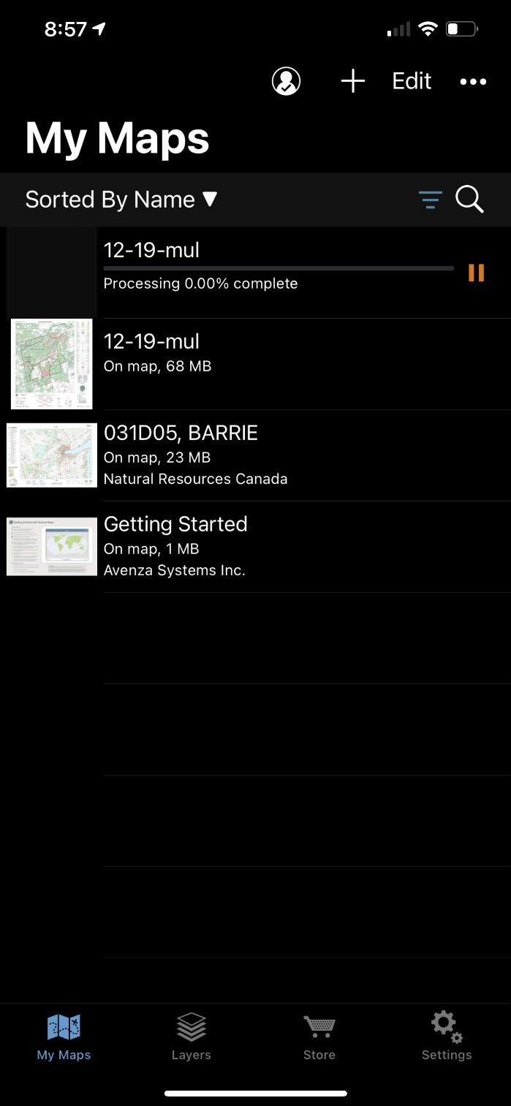
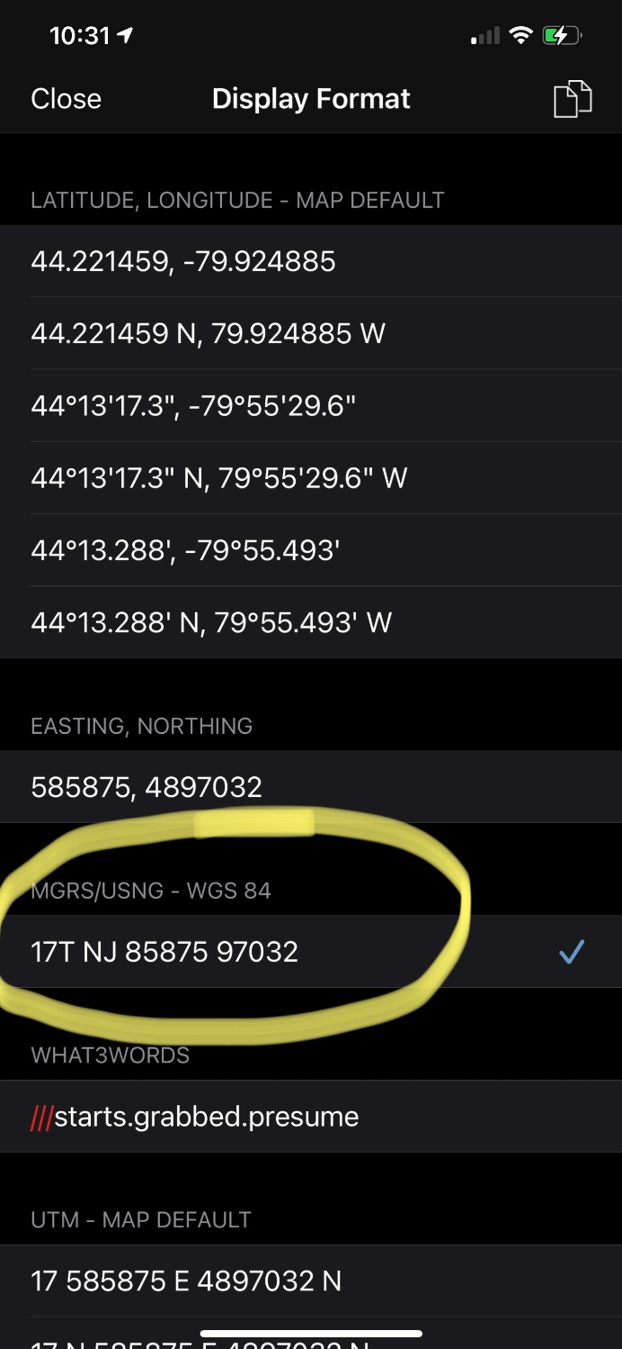
- You can then open the app and edit where your locations are also for the 10-figure grid reference go to setting and change it to MGRS/USNG – WGS 84, TO ACCESS THIS MENU CLICK THE COORDINATES ON THE BOTTOM OF THE MAP

